The 2nd Global Conference “WOMEN DELIVER: delivering solutions for girls and women” was held from 7-9 June, 2010, in Washington, DC, USA. Attending the conference and promoting the role of breastfeeding for the health and wellbeing of girls and women were:
- Miriam Labbok, Professor of the Practice of Public Health and Maternal and Child Health Director, Carolina Breastfeeding Institute
- Rae Davies, Trainer, The Birth Company
- Maureen Norton, Cognizant Technical Officer, USAID
- Rebecca Magalhães, Co-coordinator, WABA Mother Support Task Force
- Chris Mulford, Co-coordinator, WABA Women and Work Task Force;
- Elaine Petitat-Cote, Human Rights Office, IBFAN-GIFA.

WABA supported their efforts through funding conference registrations and on-site expenses and through the provision of materials for handing out and also the availability of 1,000 pencils for distribution, bright orange with the following text “After WOMEN DELIVER, they breastfeed! www.waba.org.my”. In brief, the breastfeeding message was brought to the conference in the following ways:
- Dr. Labbok, Rae, and Maureen presented a concurrent breakout session titled “Breastfeeding, Birthing Practices, and Birth Spacing: Synergistic Interventions for Maternal Health and Survival.” The session covered Breastfeeding, Birth Intervals and Birth Practices as essential to maternal health. Miriam Labbok highlighted the importance of breastfeeding for maternal health, Maureen Norton presented the evidence that birth spacing contributes to maternal health and child health and survival, while Rae Davies presented the IMBCO which is working to change maternity practices to be both more mother and breastfeeding supportive. The session was enthusiastically received by those in attendance.
- Elaine was a presenter with Naomi Cassirer of the ILO in a concurrent breakout session titled “Partnering Across Sectors: Women, Work, and Maternal Health.” She spoke in the name of IBFAN-GIFA, of of the WABA Women and Work Task Force, as well as of the Maternity Protection Coalition. She underlined the need to bring a breastfeeding perspective into the maternity protection discussion. The issue of maternal health/reproductive health/breastfeeding and work is not high on the WOMEN DELIVER agenda, although ILO (N. Cassirer) was on the advisory board of organizers. However, there has been progress since 2007 when “women and work” was hardly discussed at all. It is important that there be close contact with ILO in view of the next WD Conference so to take part again in one of their sessions and possibly include work in the session we hope to organize then.
- In pre- conference planning and correspondence, WABA was not able to reserve a time slot at the Speakers’ Corner, an ongoing opportunity to inform participants on a particular topic or issue. However, during the Conference, through an informal encounter with the staffer in charge, Chris learned that a time slot on the final day had opened, resulting in the implementation of a 15 minute presentation. The presentation was done in a high-traffic lobby area from a small stage (or large soap box) provided with a microphone. Chris sang a breastfeeding “power song” entitled “Uppity Mamas,” and Elaine made a few remarks in French. This attracted a sizable group of listeners (more than 20). Chris’s main point was the need to “mainstream” breastfeeding across all maternal-newborn-child health programs and projects. Meanwhile, the other team members distributed pencils and engaged passers-by in conversation.
- Rebecca had many1:1 encounters with participants on the topic of breastfeeding. She also asked a question at an open mike for a Chairman’s Session “Integration: Is It the Holy Grail?” on whether any of the panelists could speak to the integration of breastfeeding in their programs, receiving positive responses from all the panelists. Rebecca also distributed many pencils to individual participants and kept two booths (CORE booth and AED booth) in the Exhibit Hall furnished with pencils.
- Chris and Elaine were able to talk with Gunilla Essner at a reception. They asked her advice about a strategy to raise the profile of breastfeeding, which was getting lip service at best but mostly being ignored as a key element in maternal-newborn-child health and survival. She gave us three useful points of advice.
a) In order to help make the point that breastfeeding belongs on the SRHR agenda, the Swedish national policy on sexual and reproductive health and rights, which she wrote and which includes breastfeeding in a key position should be utilized as a reference.
b) Gunilla suggests that WABA liaise with the International Confederation of Midwives. They have also been sidelined on the WOMEN DELIVER agenda, and they are not staying quiet.
c) WABA’s gender approach, youth focus, and men’s focus should all come in handy as WOMEN DELIVER is addressed by WABA in the future. Highlight these.
- Chris attended three workshops in a “parallel” event being presented by Countdown to 2015, an initiative that tracks progress toward MDGs 4 & 5. The editor of Lancet was a prominent voice—he may have had a hand in starting this group. They focus on gathering and presenting data about interventions and outcomes in the 68 target countries that account for 97% of MNC deaths. Several speakers in the Countdown workshops did mention breastfeeding, and it is one of the outcomes that they track and report about. For example, Cesar Victora reported on the outcomes of breastfeeding promotion campaigns in Brasil, where the mean duration of “any” breastfeeding has risen from 2.5 months in 1974 to 14 months in 2006-07, and child death from infections has dropped significantly. Economic factors also played a role in the improvement of child health during this period.
- Chris made an intervention at a Countdown workshop to thank them for keeping breastfeeding on their agenda, for publishing data about breastfeeding, and for “getting it” that breastfeeding is a key topic in MNCH. Many people spoke to her afterwards—mostly these were other listeners, not speakers.
- Countdown launched its preliminary report at the WOMEN DELIVER conference. It is available on line at www.countdown2015mch.org/. A letter that may be utilized by WABA to respond to the report is currently being drafted by Chris and Miriam.
- Elaine participated in several sessions related to Human Rights but the issues did not touch on the right to food or child rights and breastfeeding was not referred to.

Although breastfeeding was not featured or included at the WD Conference, it was apparent that breastfeeding fit in many ways and areas and, with minimal resources, this small group of dedicated women was able to bring the issue of breastfeeding to conference participants and place it front and center! Thanks to WABA for its part in making this happen. The pencils were a huge success and afforded the group members with a reason to approach and engage participants in a conversation on breastfeeding.

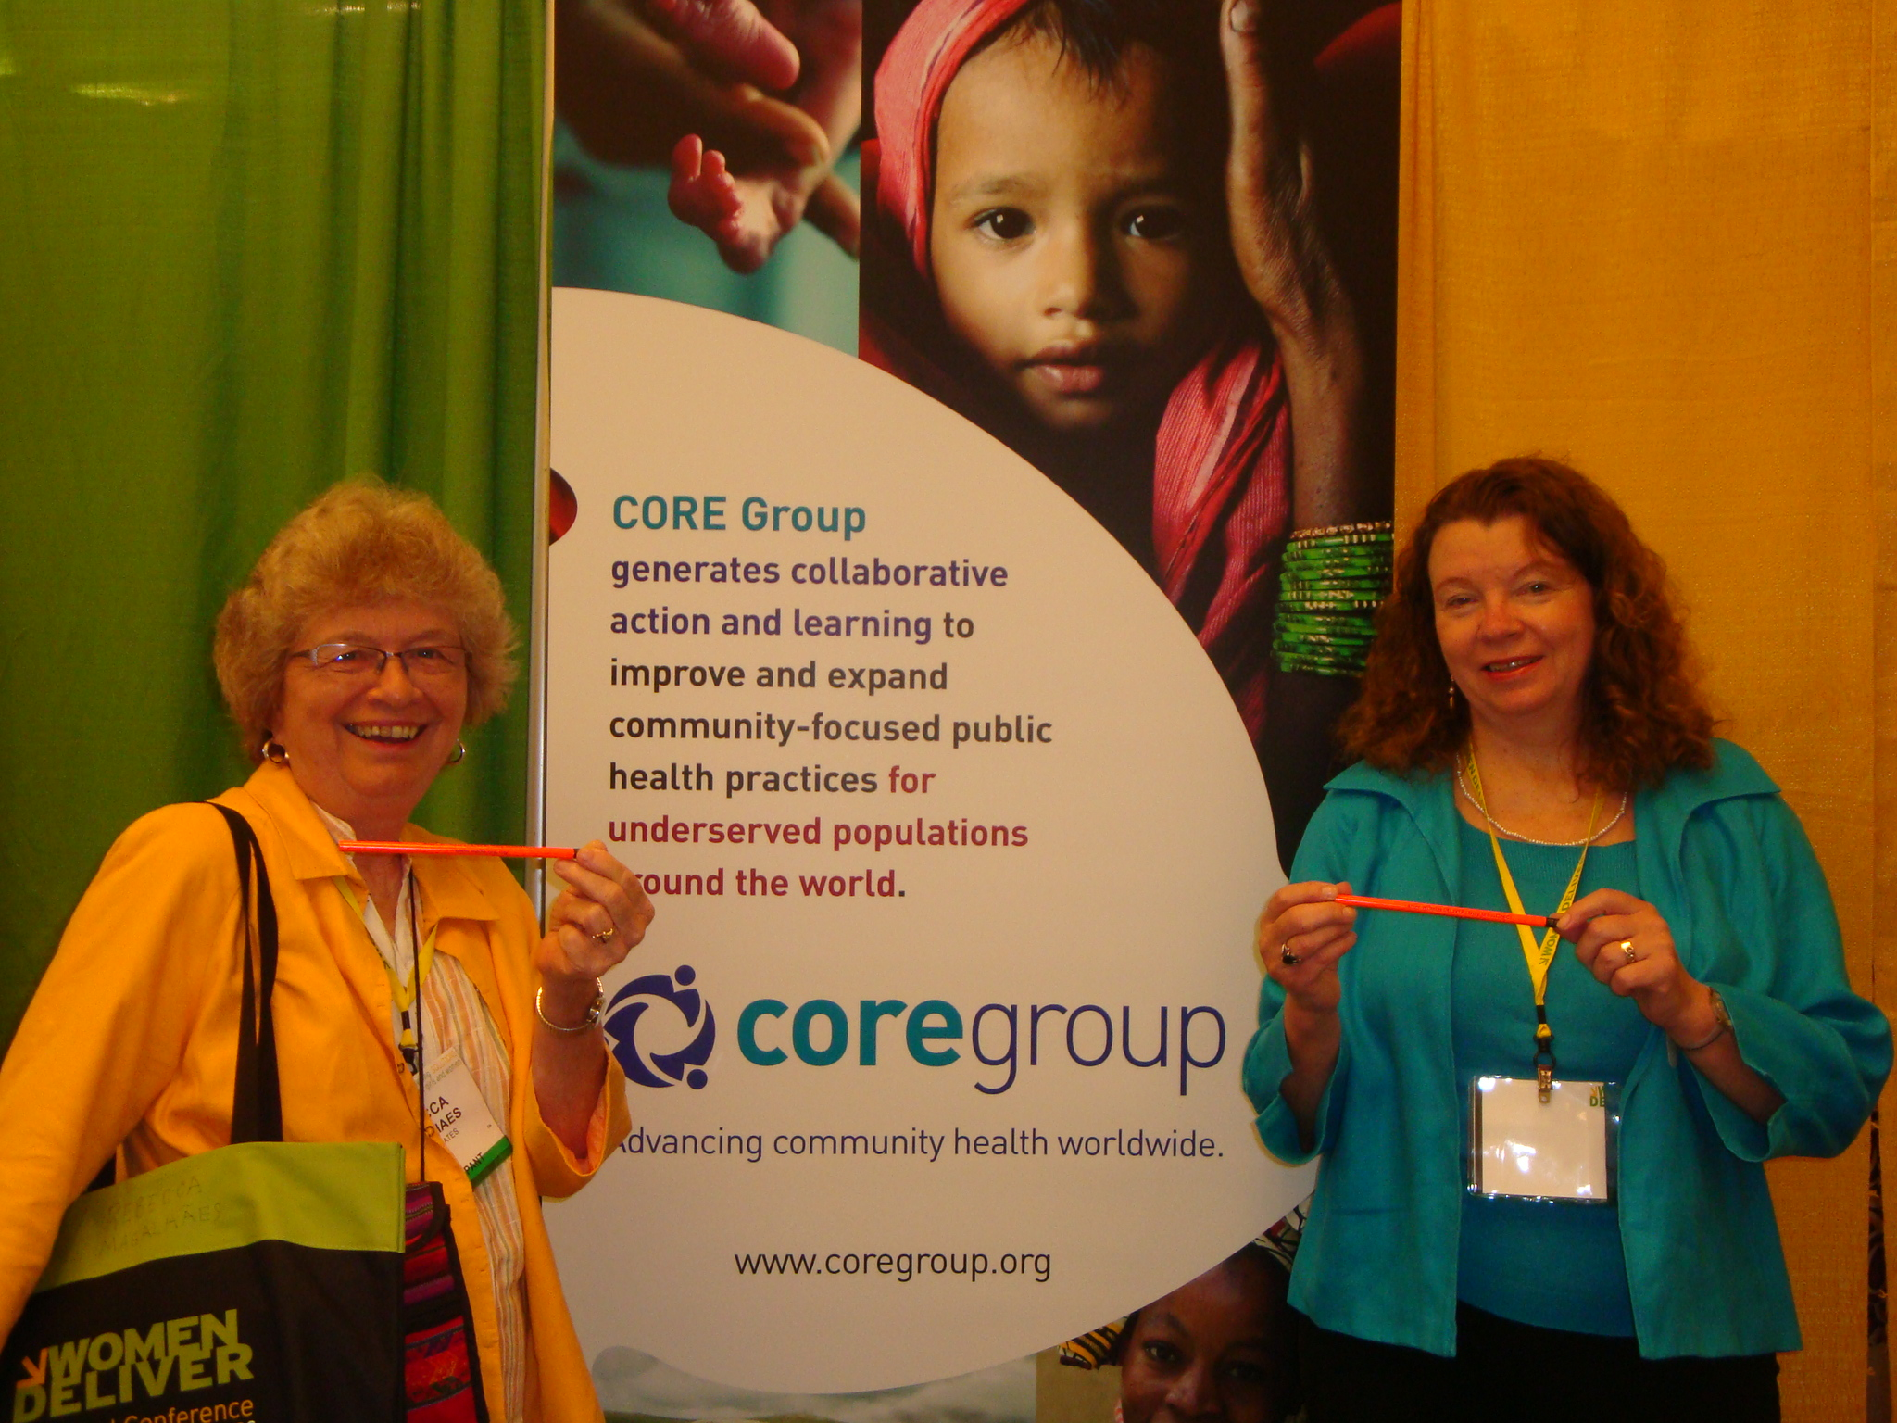
Rebecca networking with other participants by sharing the breastfeeding message pencil
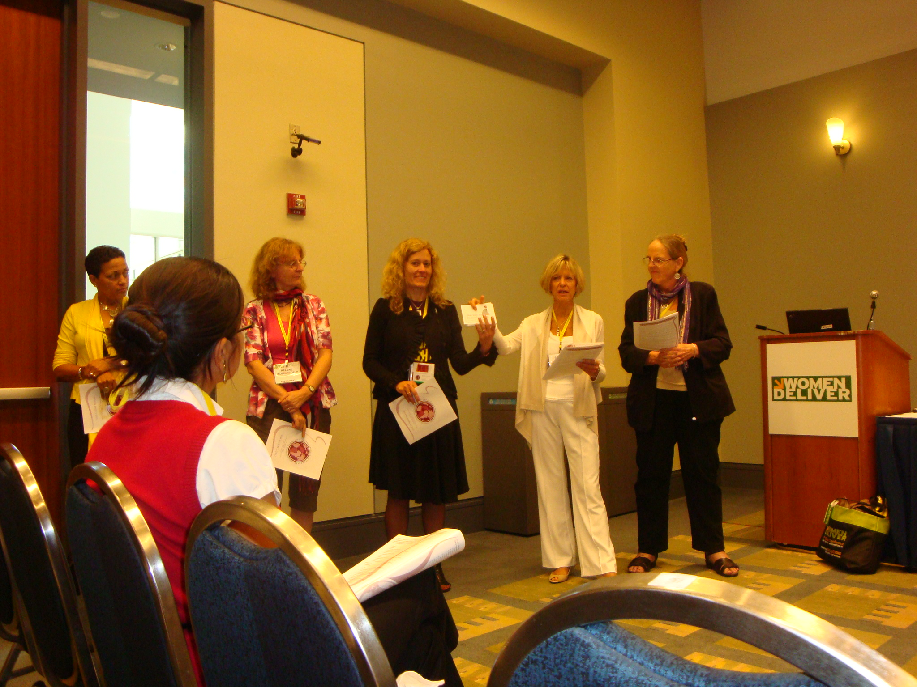
Rae with participants of the Breastfeeding, Birthing Practices, and Birth Spacing: Synergistic Interventions for Maternal Health and Survival workshop session

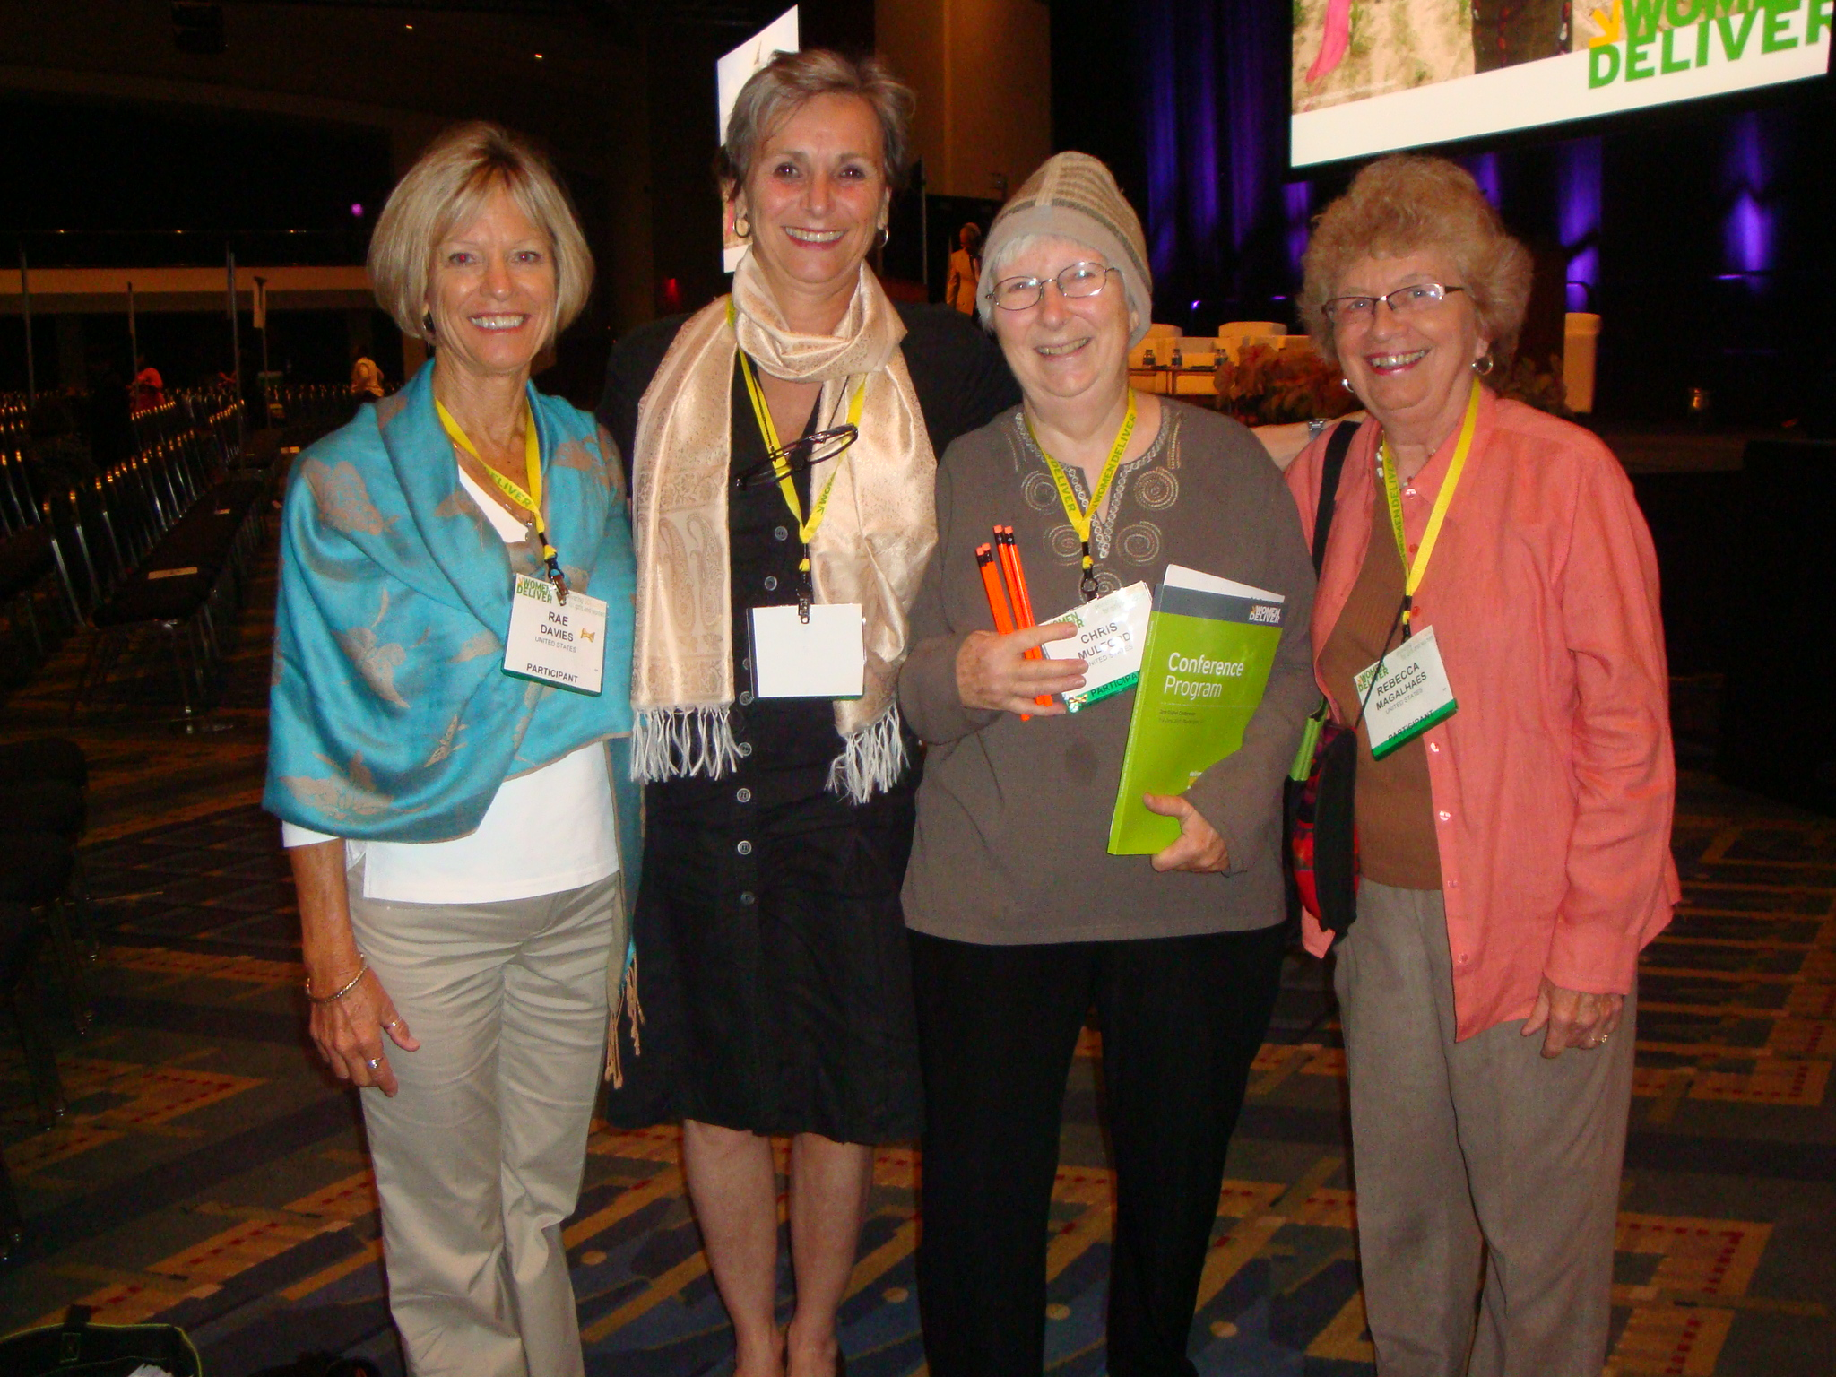
Some of the WABA reps : From Left – Rae Davies, Elaine Cote, Chris Mulford and Rebecca Magalhaes.

