The global Breastfeeding Initiative for Child Survival (gBICS)

A worldwide Civil Society Initiative to improve infant health and development

 | 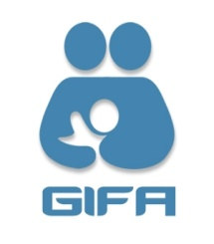 | 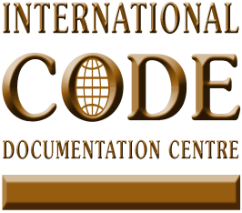 | 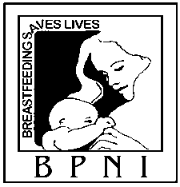 | 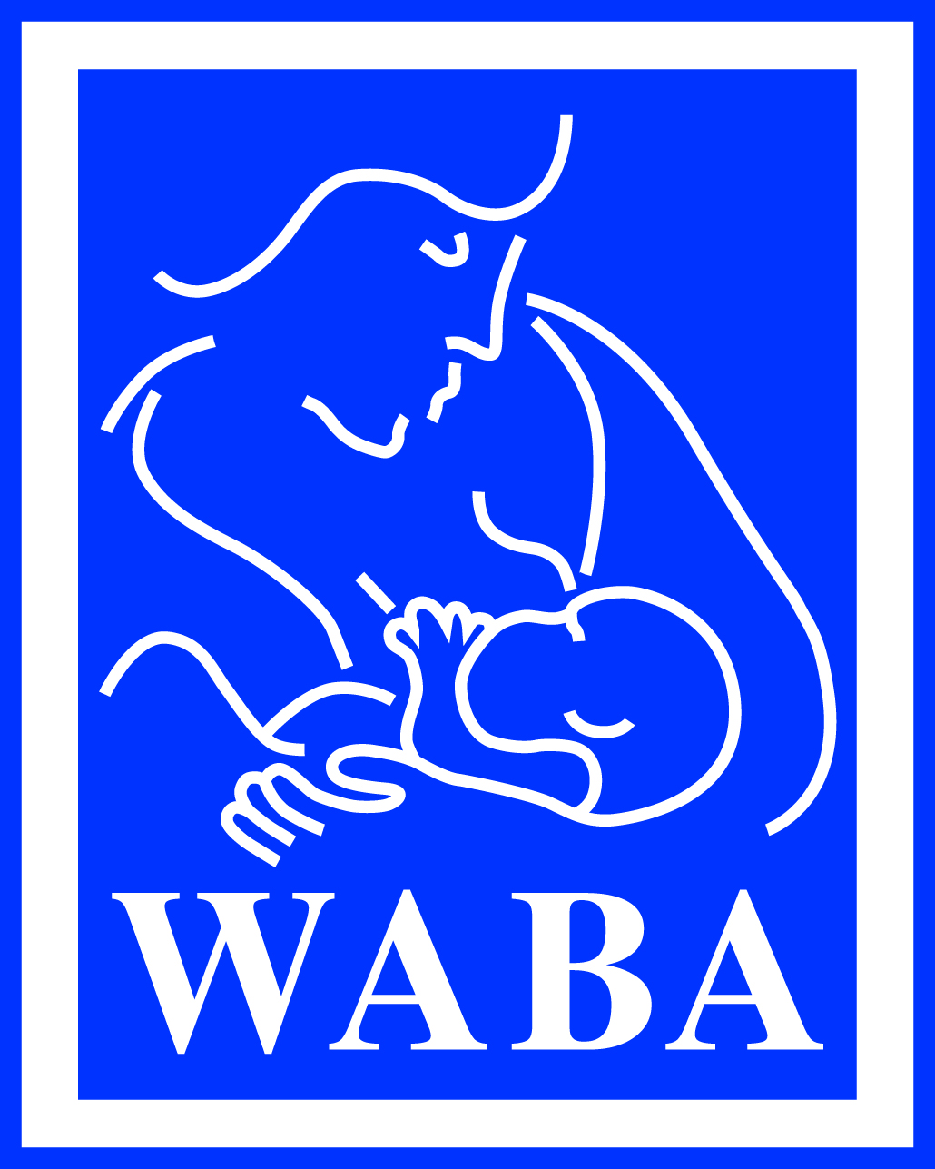

The global Breastfeeding Initiative for Child Survival (gBICS)
The gBICS is a worldwide civil society-driven initiative aiming to accelerate progress in attaining the health-related Millennium Development Goals (MDGs) by 2015, especially Goal 4, reduction of child mortality, by scaling up early, exclusive and continued breastfeeding.
The gBICS can be portrayed as the process of building a house that sets in motion the realisation of the rights of children to the highest attainable standard of health by protecting, promoting and supporting breastfeeding. The idea is to represent a home where breastfeeding is successfully and naturally practiced.
The builders of the house are civil society groups (including NGOs, health professional associations, public interest groups, trade unions and the media) working together with their governments and national authorities to identify the important floors and rooms to construct. The building process will be shaped by the information provided by an assessment tool, developed by the Breastfeeding Protection Network of India (BPNI), known as the World Breastfeeding Trends initiative (WBTi). More information at: www.worldbreastfeedingtrends.org
The WBTi targets the national level. It brings governments and civil society partners together to analyse the situation of Infant and Young Child Feeding, basing the analysis on a series of key indicators. The outcome provides guidance as to what actions are required. WBTi has the built-in possibility to monitor progress and repeat assessments to measure change.
The foundations of the house have been laid by the Global Strategy for Infant and Young Child Feeding (GSIYCF) and by the second Innocenti Declaration of 2005 which further includes environmental and food safety issues.
The Global Strategy is firmly anchored in human rights principles and sets out the obligations and responsibilities of each concerned party, including commercial enterprises. Paragraph 44 spells out their two obligations: to conform to the International Code and to comply with Codex Alimentarius Commission standards.
The Global Strategy has given strong impetus to infant and young child feeding in especially difficult circumstances, such as humanitarian crises and the HIV/AIDS context. In these circumstances all the building blocks of the strategy to construct a 'national house' that would protect, promote and support child survival, growth and development become even more important. The building blocks will not change, but the emphasis on each and every block will shift, depending on whether policies and programme are defined and developed in countries with high HIV prevalence, or in countries that are exposed to various types of emergencies.

International policy instruments address the urgent need to protect, promote and support optimal breastfeeding and infant and young child feeding practices:
- The 1981 International Code of Marketing of Breastmilk Subsitutes;
- The 1990 Innocenti Declaration on The Protection, Promotion and Support of Breastfeeding;
- The 1992 Baby-Friendly Hospital Initiative;
- The 2002 Global Strategy for Infant and Young Child Feeding (GSIYCF);
- The Human Rights Framework:
  - The Universal Declaration of Human Rights;
  - The International Covenant on Economic, Social and Cultural Rights and its General Comment no 14;
  - The Convention on the Elimination of All Forms of Discrimination Against Women;
  - The Convention on the Rights of the Child.

Building gBICS at national level
As an initiative, the gBICS implies a process of bringing on board traditional as well as new allies and rallying them around the common purpose expressed in the general objective: to mainstream breastfeeding protection, promotion and support in the Global Campaign for the health-related Millennium Development Goals, led by Norway.
The World Breastfeeding Trends Initiative (WBTi) will provide the doorway and stairway for this process at country level. The WBTi is a participatory process bringing together governments, civil society, UN agencies and professional associations as partners. Following the principles laid down by the Global Strategy for Infant and Young Child Feeding (GSIYCF), the producers of breastmilk substitutes are not a partner. Civil society is the key facilitator that builds momentum for actions resulting in lasting improvements.
Protection of optimal infant feeding practices forms the ground floor of the gBICS house. This is the critical element to provide the sound basis for promoting and supporting breastfeeding by removing major obstacles or by protecting against forces that can undermine optimal breastfeeding practices. IBFAN's mandate lays special emphasis on protecting breastfeeding, advocating for the rule of law to provide sustainable protection through enforcement and monitoring mechanisms. The International Code and its subsequent relevant resolutions, the Convention on the Rights of the Child, the ILO Conventions and policies on Infant Feeding in Emergencies and in the context of HIV/AIDS provide the basis for key rooms to be built in each country. The Baby-Friendly Hospital Initiative (BFHI) was initiated by UNICEF in 1992. The new WHO/UNICEF package has been designed to revitalise the BFHI, with increased emphasis on skin-to-skin contact, early support, assessment of compliance with the International Code and improved criteria for hospital re-assessment.

Promotion of optimal infant feeding represents the first floor. The activities of both IBFAN and WABA aim to promote optimal breastfeeding and infant feeding practices through information, education and communication campaigns. IBFAN’s national level activities traditionally include promotion of breastfeeding by inducing cultural change that will make it the norm. WABA's mandate is to increase efforts for social mobilisation and outreach to include more allies from both inside and outside the breastfeeding movement. The World Breastfeeding Week (WBW) is a successful and efficient way of drawing the attention of the general public and the media about the benefits of breastfeeding.
Support for optimal infant feeding forms the second floor. This floor includes transformed health care practices in hospitals, through implementation of the BFHI, and in clinics and health centres and community health services. These provide mothers and children with breastfeeding counselling and optimal infant and young child feeding counselling, through regular contacts with skilled health workers from birth for two years or beyond. WABA and IBFAN both help to train health workers for these tasks. Both have the capacity to bring all of IBFAN’s traditional allies and WABA’s Core Partners: Academy of Breastfeeding Medicine (ABM), International Lactation Consultants Association (ILCA) and Wellstart international into the gBICS.
Floor 2 also includes ongoing support from community peer counsellors and mother support groups to sustain exclusive and continued breastfeeding and complementary feeding. WABA is actively involved in promotion of mother support groups, in collaboration with its core partner La Leche League International (LLLI), country groups, and other national mother support group initiatives.
The second floor also includes support for working mothers with crèches and breastfeeding facilities at the workplace. This work is guided by WABA and implemented by IBFAN groups at the regional and national levels.
The roof of gBICS is provided by international human rights instruments which clearly identify the rights holder s and the duty bearers. States parties realize their obligations to respect, protect and fulfil these rights. International recommendations and Conventions provide the protection of the rule of law when these are implemented into national legislation that can be enforced and monitored.
The gBICS will evolve and become a worldwide campaign, where all the organizations working for the protection, promotion and support of breastfeeding will participate and contribute. IBFAN and WABA started the process and will steer it until it gains the necessary momentum to stand on its own.
The gBICS house is shown in the diagram below:
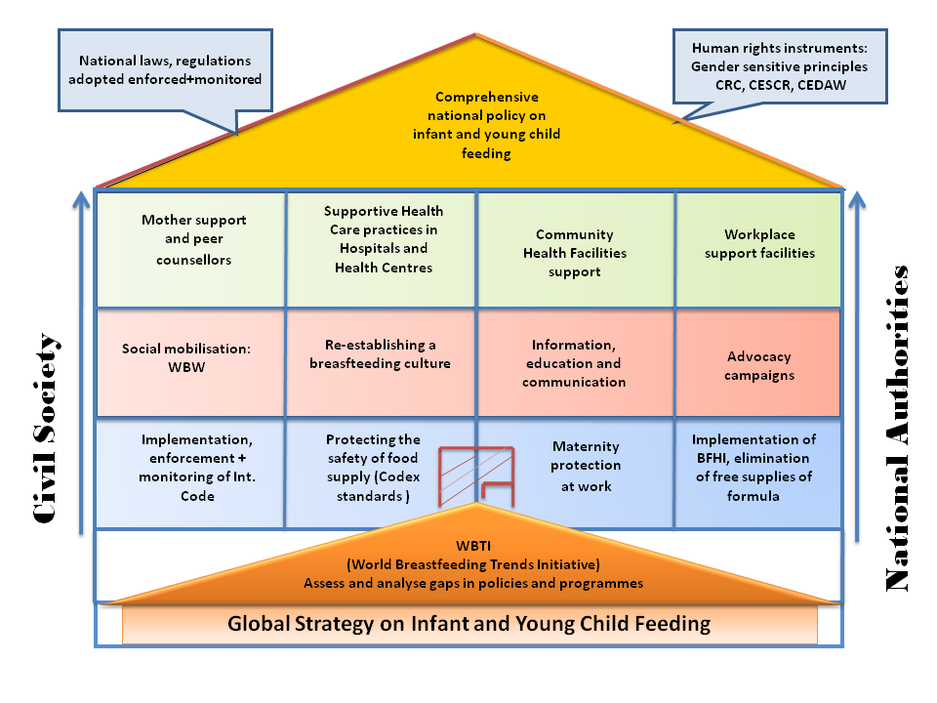

We would like to acknowledge Dr. Elisabeth Helsing who conceived the original diagram in 2003 as a Framework for a Human Rights Based Infant Nutrition Policy, and with whom we have discussed this adapted version.
Manufacturers and distributors of industrially processed foods intended for infant and young children, should ensure that processed food products, when sold, meet applicable Codex Alimentarius Commission standards and the Codex Code of Hygienic Practice for Foods for Infants and Children…. They are responsible for monitoring their marketing practices (including for feeding bottles and teats) and ensure that their conduct at every level conforms to the International Code, subsequent World Health Assembly resolutions and national measures adopted to give effect to both".

